**Testing Documentation**

|  |  |
| --- | --- |
| **Test 1** | |
| **Description** | When in the beginning we enter education level other than ‘c’, ‘C’, ‘Q’, ‘q’, ‘u’, ‘U’, ‘h’, ‘H’. Next, we enter any invalid letter in upper case. Then we enter ‘q’ |
| **Input** | s, N, q |
| **Expected Output** | Error!  Error!  Average salary=$0.00 for university degree, average salary=$0.00 for college diploma and average salary=$0.00 for high school |

**Actual Output**

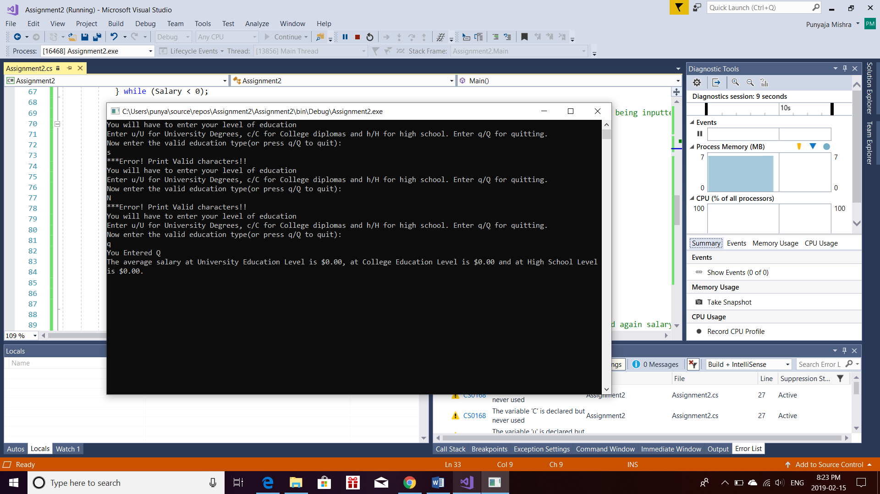

|  |  |
| --- | --- |
| **Test 2** | |
| **Description** | We enter education level as university degree then salary for it. Then enter q for quit |
| **Input** | u, 15000, q |
| **Expected Output** | Average salary=$15000.00 for university degree, average salary =$0.00 for college diploma and average salary=$0.00 for high school |

**Actual Output**

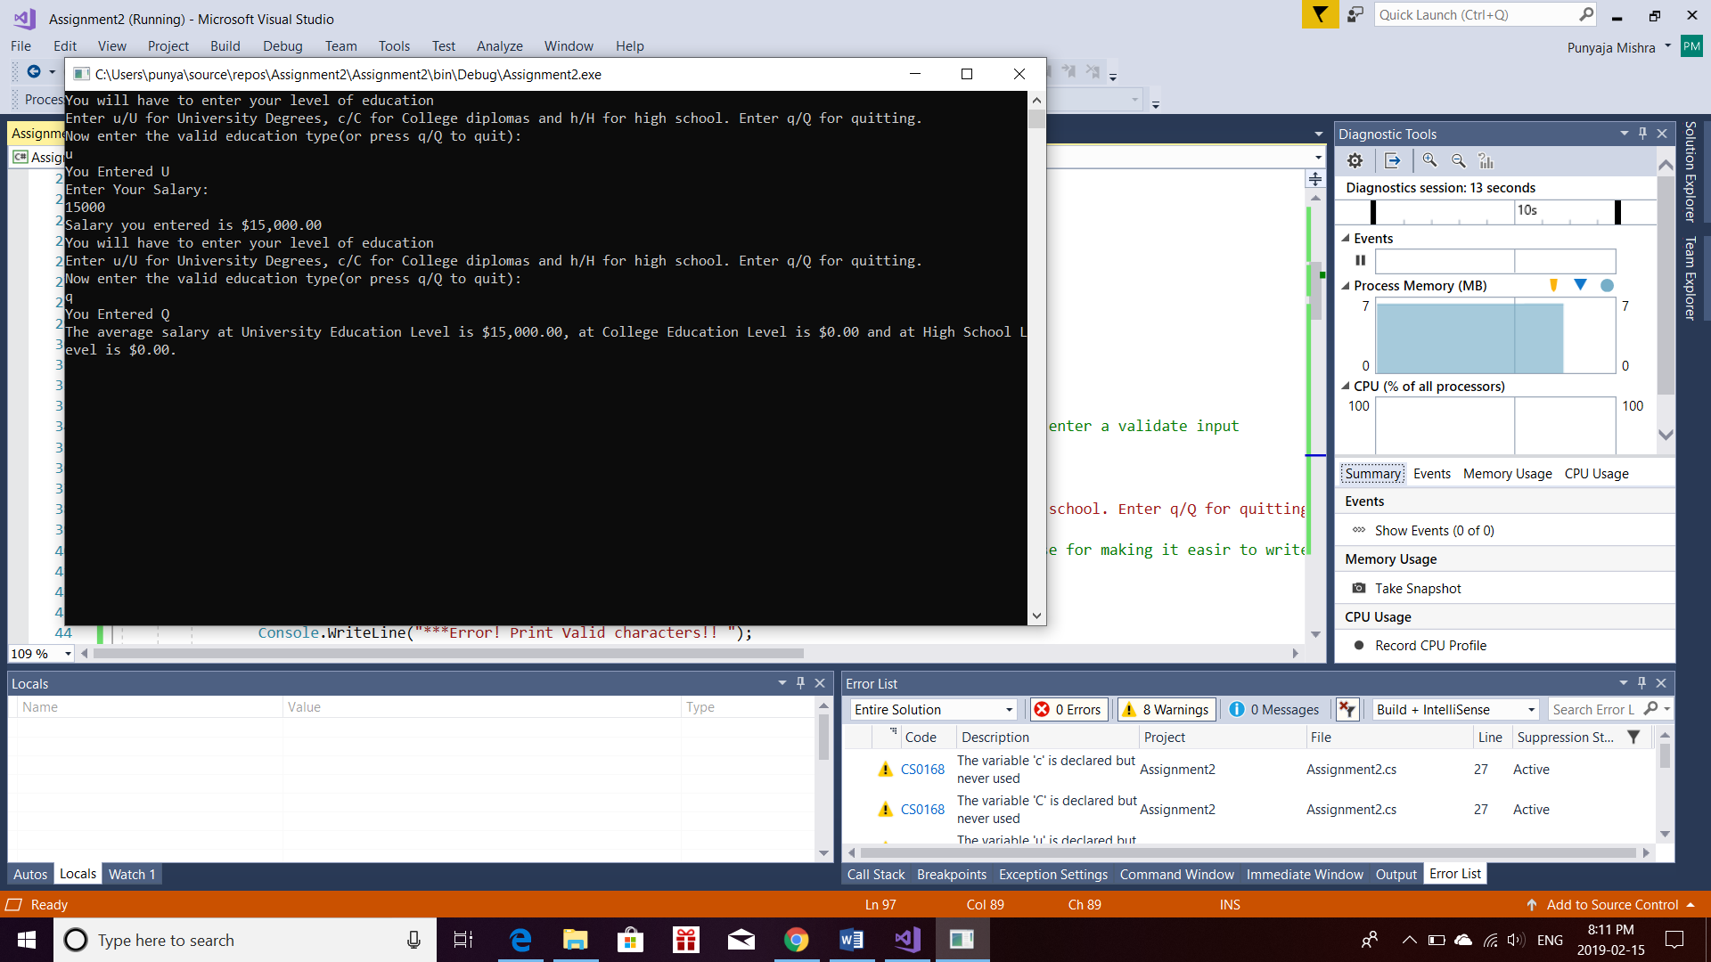

|  |  |
| --- | --- |
| **Test 3** | |
| **Description** | We enter education level as college diploma then enter salary for it and enter q for quitting |
| **Input** | c, 12000, q |
| **Expected Output** | Average salary=$0.00 for university degree, average salary =$12000.00 for college diploma and average salary=$0.00 for high school |

**Actual Output**

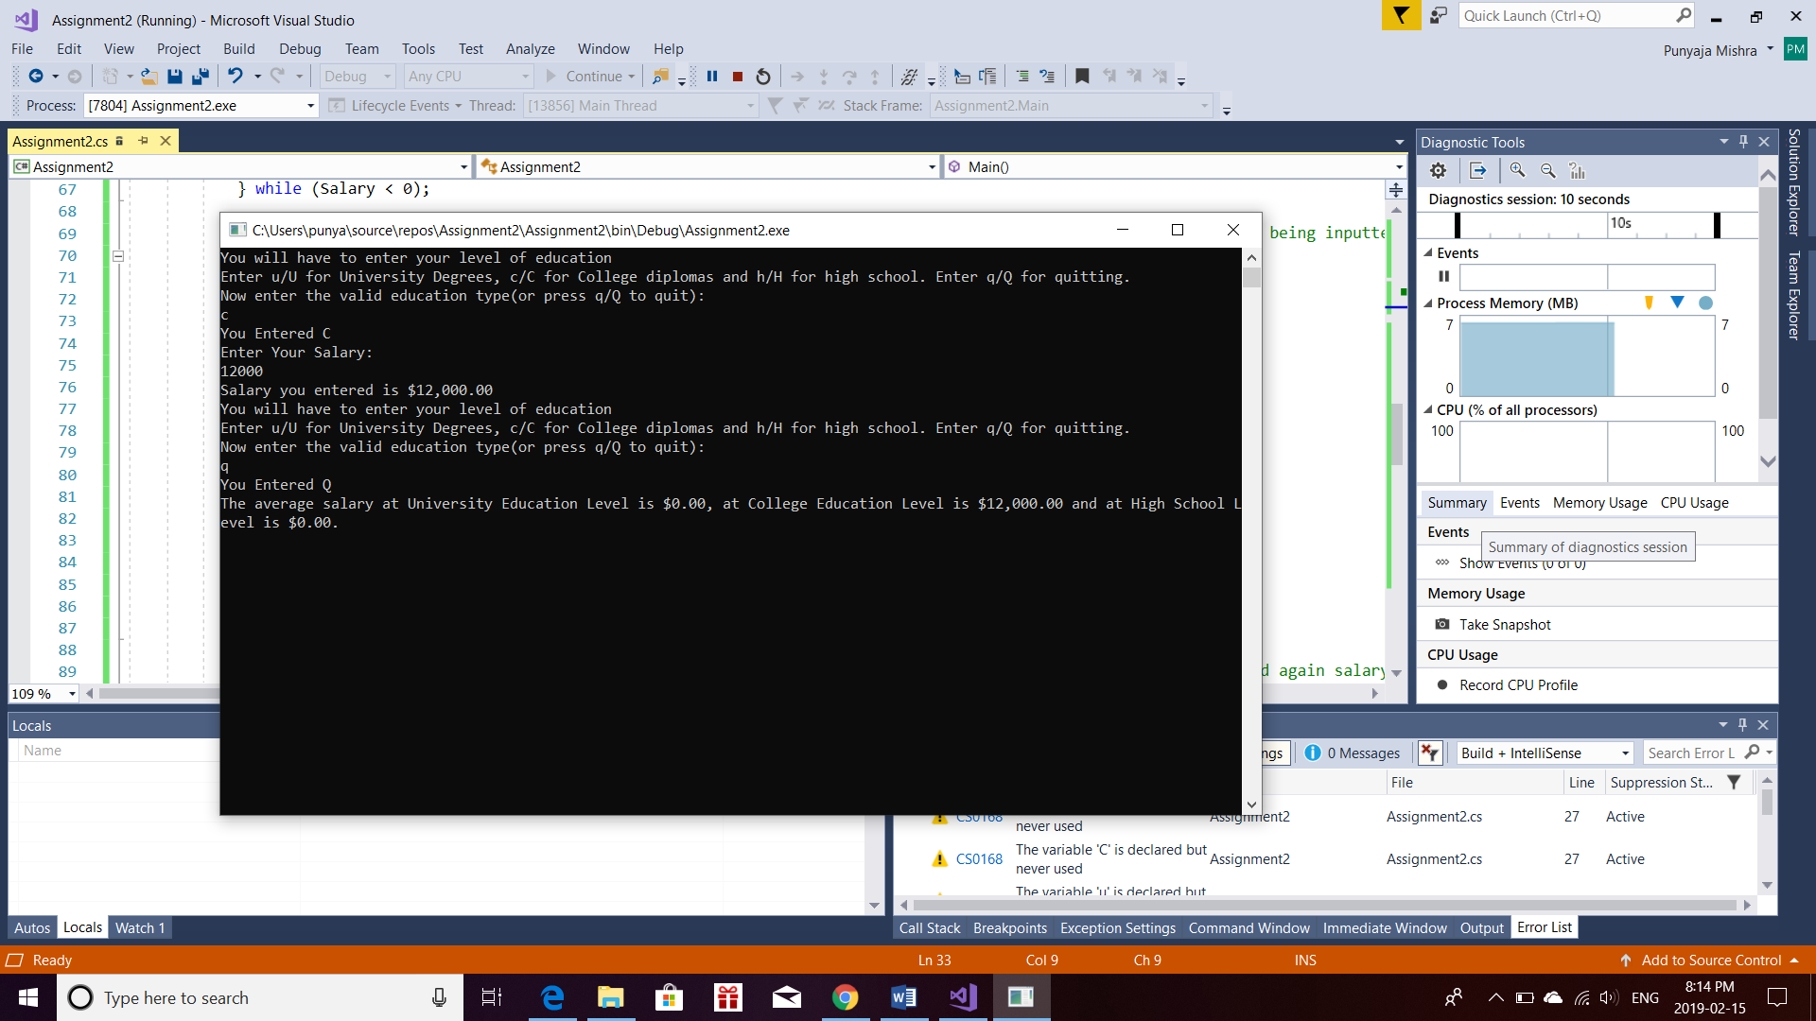

|  |  |
| --- | --- |
| **Test 4** | |
| **Description** | We enter education level as high school then enter salary for it and enter q for quitting |
| **Input** | h, 10000, q |
| **Expected Output** | Average salary=$0.00 for university degree, average salary =$0.00 for college diploma and average salary=$10000.00 for high school |

**Actual Output**

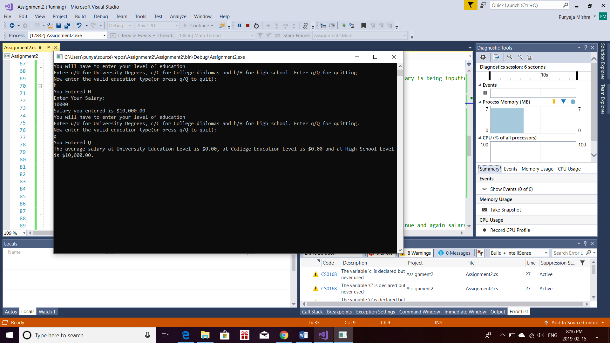

|  |  |
| --- | --- |
| **Test 5** | |
| **Description** | We enter education level as university degree then enter salary for it. Then enter university degree again and a salary value for it, then we enter a college diploma and salary then again college diploma and salary then we enter high school then salary, again high school and salary. Basically, two for each education level and then we enter q for quitting. This time we use upper case letters as well. |
| **Input** | U, 25000, u, 30000, c, 20000, C, 19000, H, 10000, h, 14000, Q |
| **Expected Output** | Average salary=$27,500.00 for university degree, average salary =$19,500.00 for college diploma and average salary=$12000.00 for high school |

**Actual Output**

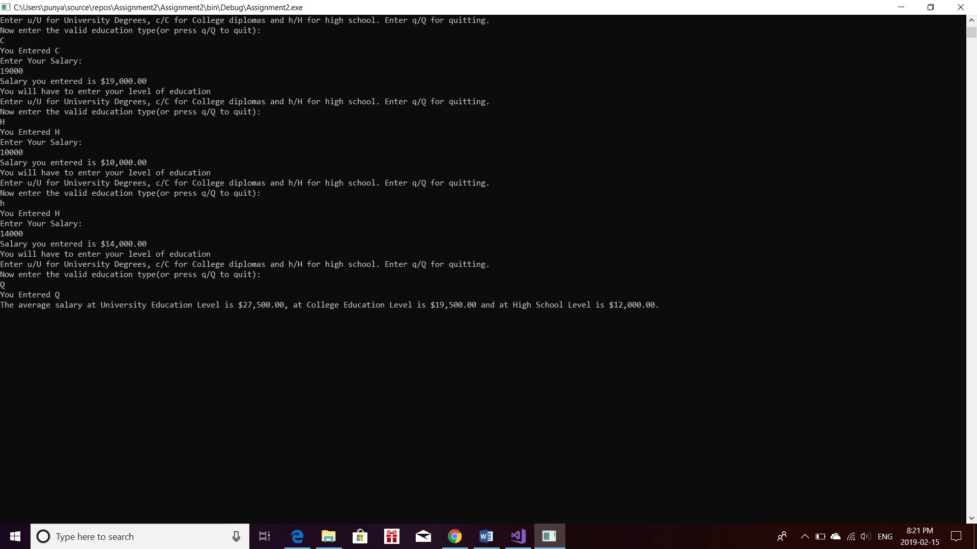

|  |  |
| --- | --- |
| **Test 6** | |
| **Description** | We enter 2 education levels u, c and salaries thrice and then quit |
| **Input** | u, 25000, c, 14000, U, 29000, U, 30000, C, 20000, c, 21000, Q |
| **Expected Output** | Average salary=$28,000.00 for university degree, average salary =$18,333.33 for college diploma and average salary=$0.00 for high school |

**Actual Output**



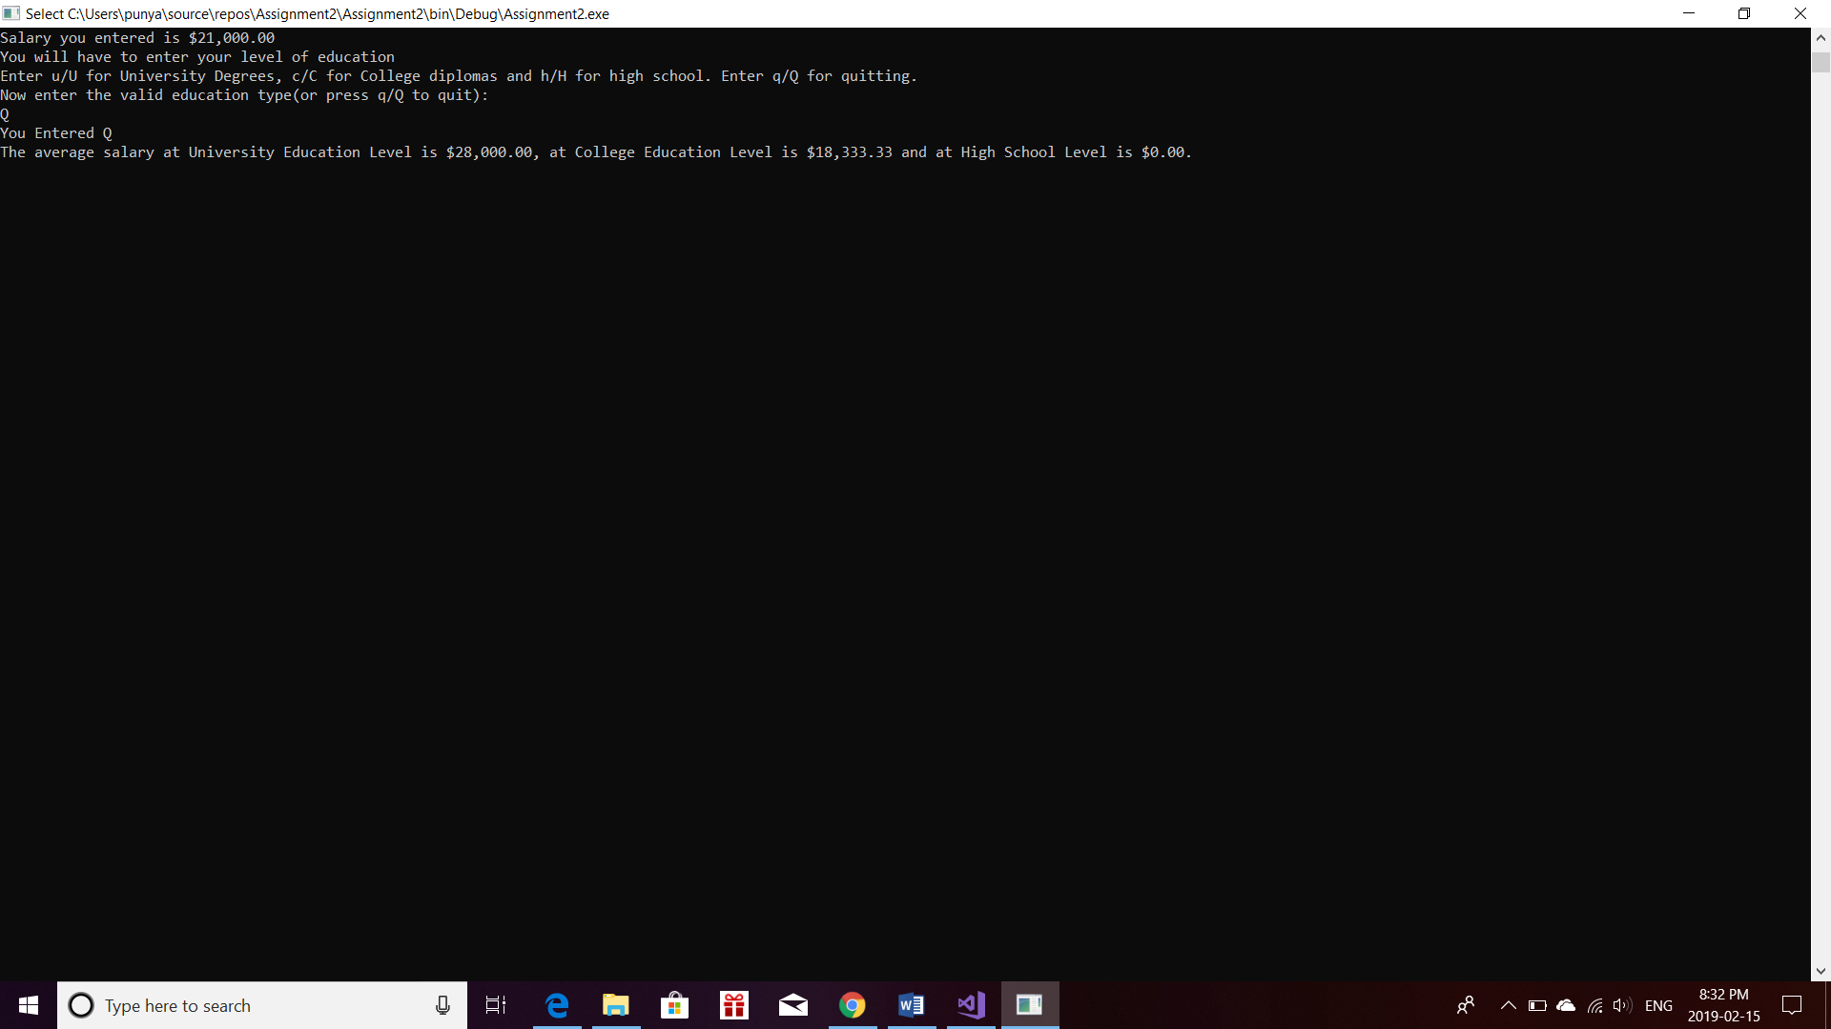

|  |  |
| --- | --- |
| **Test 7** | |
| **Description** | We enter 2 education levels u, h and salaries thrice and then quit |
| **Input** | u, 25000, h, 10000, U, 29000, h, 11500, U, 30000, H, 12000, Q |
| **Expected Output** | Average salary=$28,000.00 for university degree, average salary =$0.00 for college diploma and average salary=$11,166.67 for high school |

**Actual Output**



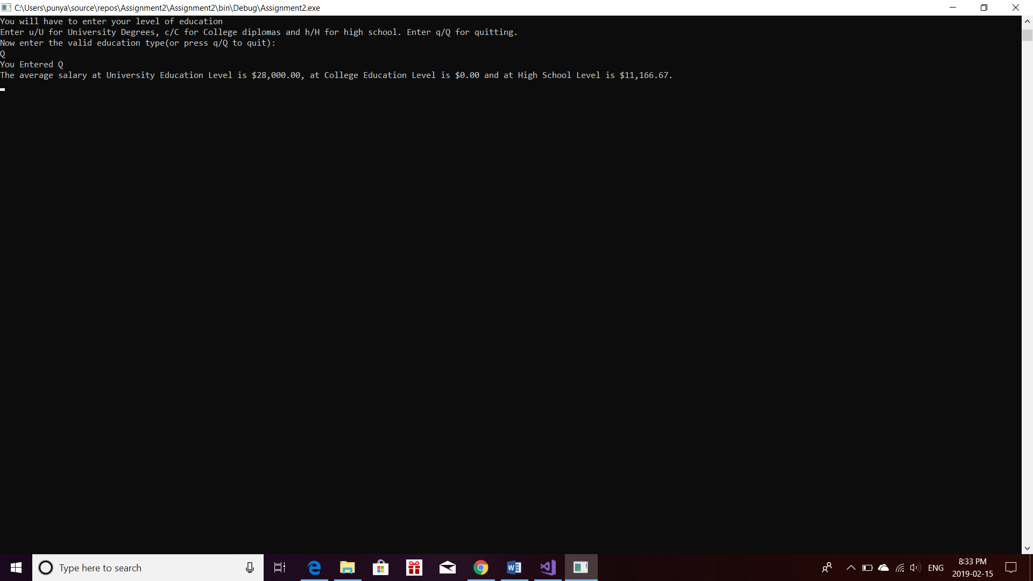

|  |  |
| --- | --- |
| **Test 8** | |
| **Description** | We enter 2 education levels c, h and salaries thrice and then quit |
| **Input** | c, 21000, h, 10000, C, 20000, h, 11500, C, 22000, H, 12000, Q |
| **Expected Output** | Average salary=$0.00 for university degree, average salary =$21,000 .00 for college diploma and average salary=$11,166.67 for high school |

**Actual Output**



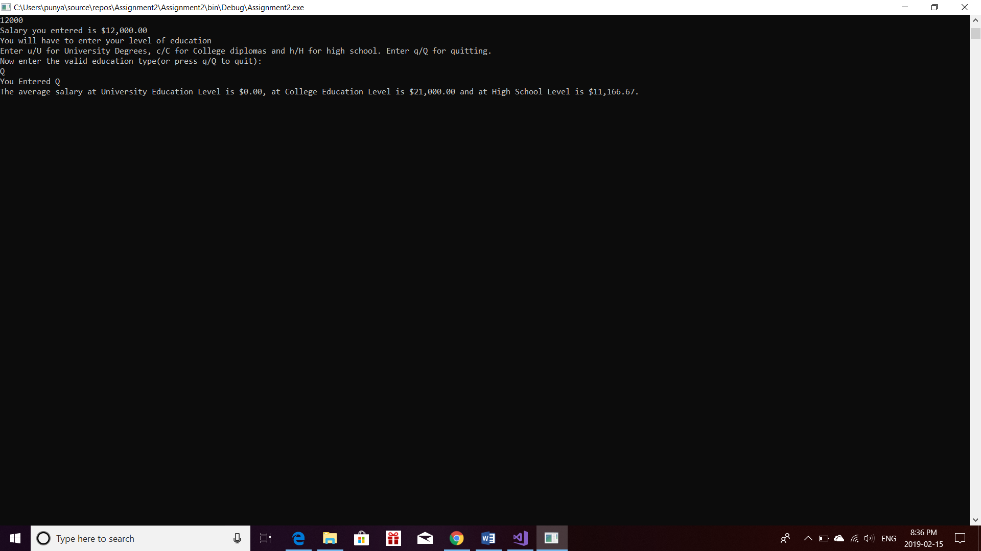

|  |  |
| --- | --- |
| **Test 9** | |
| **Description** | We enter an education level then an invalid letter then again, a valid letter and so on till we enter. To check if program works if invalid letter is printed in between |
| **Input** | U, 30000, s, c, 15000, U, 27000, h, 10000, H, 11000, Q |
| **Expected Output** | Average salary=$28,500.00 for university degree, average salary =$15,000 .00 for college diploma and average salary=$10,500.00 for high school |

**Actual Output**

